The INSPIRE Project, Inc.

107 S West Street

PMB # 425

Alexandria, VA 22314-2824

Dear DR. WILLIAM W.L. "BILL" TAYLOR MEMORIAL SCHOLARSHIP Committee,

I am writing to recommend Kuishon Brown for a scholarship from The INSPIRE William Taylor Memorial Scholarship Program. Kuishon has been involved in The National Society of Leadership and Success at Howard University and has completed a rigorous leadership training program through our organization.

I'm sure you know that leadership skills are important in any successful business. That is why I think Kuishon would be an excellent candidate for your organization. Kuishon has chosen to attend many hours of training focusing on team work, goal setting, high achievement, leadership skills and styles, self-motivation, and accountability. Instead of needing to learn these skills on the job, Kuishon will come to your organization with them already developed. Through many hours of hard work and after being reviewed by both the staff at his college as well as the national office, Kuishon has been awarded a Certificate of Leadership Training.

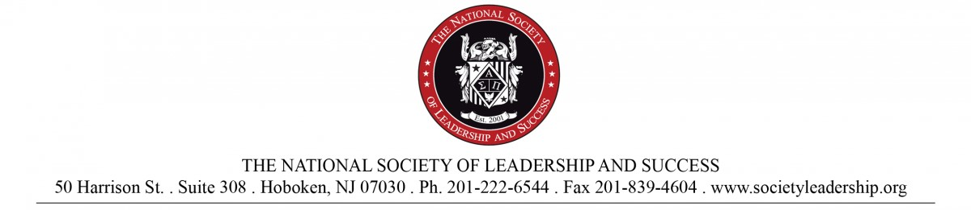If you have not heard of The National Society of Leadership and Success' certification program, you may not realize how much work is involved for a member to achieve this status. Since joining, Kuishon has attended training broadcasts with presenters such as Dr. Stephen Covey, Jack Canfield, Goldie Hawn, Harvey MacKay, and Alan Dershowitz. Additionally, through bi-weekly mastermind team meetings, he has learned how to use a peer group to increase performance. After each meeting, Kuishon completed a journal to document his progress and goals. Finally, Kuishon attended a comprehensive Leadership Training Day to tie together all of his new knowledge. The certification process is only completed by an average of 1% of the students on the campuses where our organization exists.

I hope you will consider Kuishon for a place in your company. I am sure that he would be a valuable asset to The NASA INSPIRE Online Learning Community and that his leadership certification would directly contribute to his increased performance.

Very truly yours,



Gary Tuerack

Chief Visionary

The National Society of Leadership and Success



**The INSPIRE William Taylor Memorial Scholarship Program**

May 6th, 2017

To Whom It May Concern:

With great privilege, I strongly recommend Kuishon Brown for The INSPIRE William Taylor Memorial Scholarship Program. Kuishon is one of my organization’s best students representing integrity and professionalism. As his coach, I have seen him take leaps of faith in exploring new opportunities where the rewards are intangible. From the first time that I’ve met Kuishon, he has always served as a positive role model.

In Spring 2015, Kuishon was the only freshman I met promoting the National Society of Black Engineers (NSBE) at Howard University. He was dressed like a professional engineer, well-mannered, approachable, and very helpful in providing in-depth understanding of NSBE on campus. In offering a challenge to interview for a software programming summer internship, he gladly received the offer, learned as much Java coding in one weekend as he could, and followed through. That moment, due to his initiative and optimism, is when I personally recruited him for my organization.

Since last school year, Kuishon has been an outstanding role model for several of my sophomores. With his wisdom and positive energy, my sophomores have quickly connected with him and are following his advice. Because of his gregarious personality, all of the students in our organization value him and look forward to his smiles. His peaceful humor always increases our team bond and is a great ice-breaker for new students.

There are many great qualities to his character, but the one that stands out is his leadership. He adapts quickly to new environments, initiates introductions articulately, listens respectfully to others while building meaningful connections, and loves to engage challenging opportunities especially with a team. In addition, he has been a tutor and working on weekends. Because Kuishon has a great future ahead of him, I’m proud to be one of the many who recommends him as a prospective graduate scholar and scholarship recipient for your organization. Please feel free to contact me personally with any questions or comments at gradney@gmail.com​ or 612-987-4463.

Sincerely

 Gordon Radney ; Impact Movement - Campus Ministry Coach - Howard University

The African American community in STEM – Science, Technology, Engineering, and Math – deserves stronger leadership and support not only in college life, but beyond. With increasing complexity of technology whilst more millennials, like myself, are taking key leadership roles, I feel the need to pay it forward to the next generation of engineers. The INSPIRE William Taylor Memorial Scholarship is not only an avenue for this, it’s a platform for Black excellence. Engineers are the future in more ways than one can imagine. With big collaboration efforts to improve living worldwide, effective control of leading positions rarely falls into the grasp of the African American populace. I want to bridge this gap, and create a pipeline for young Black engineers from the grassroots to be funneled into college educational programs.

The INSPIRE program is a direct means of reaching out to the neighboring community, as well as to uplift individuals with great potential. It is by no means a simple task, and I am passionate about challenging the younger generation to be flexible in thinking while acute in awareness. There are many students who fall off the radar after going through the first chapter of their careers in the sciences and mathematics. To change the spectrum of retention rates, and to help keep students in school, mentorship and efficient tutelage from their peers is a must. Creating the connection between disciplines early is also a great career building move before students graduate and join the workforce. Changing the game up by innovating and challenging the ideals that need to be revised – this is my commitment to the program.

Nothing describes me more than the phrase “pay it forward.’’ My success from a social and educational standpoint has a deep connection to the investments key figures in my life have made in me. I have been blessed, on numerous occasions, with scholarships and other monetary aid. All this has been accomplished in order to continue to pursue my education. I am forever indebted to give forth double the blessings to the next generation of scholars – specifically those pursuing a rewarding career in engineering.

There is no better feeling than to see others strive for success. Moments in life have lit a fire in my heart, all while providing clarity and direction for me. It is this clarity that made me realize the importance of the community’s growth; not just the personal. No matter much I chase after success, if others who I’ve met along the way don’t succeed, I would truly have failed. So, it’s has no longer been a notion, but a declaration when I wake every day excited about the positive change I can make in other’s lives.

