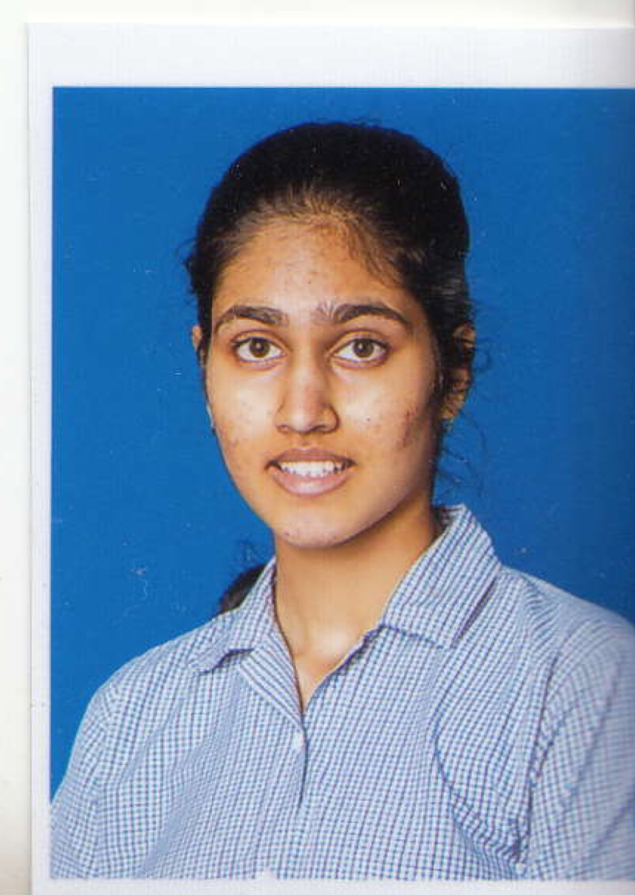**SECTION A:**

**Name: Krishi Manek**

**House: Tigers**

**Posts desired (in order of preference):**

1. Head girl

2. Student council coordinator

3. Sports coordinator

**Achievements**

Academic

* Honor roll 2016-17
* Honor roll 2018-19
* 2018-19 academic achievement awards in Geography, Biology, Physics, Chemistry, International Math, World Literature, First Language English and French
* 2018-19 effort awards in First Language English, Geography and Drama
* IGCSE grades – 9A*s and 1A in drama

Leadership

* Senior leader at ReforMumbai
* Team coordinator for byculla zoo project (BringBackTheZoo) @bringbackthezoo on instagram
* Interned at The Drama School Mumbai from 14th june to 2nd july 2019

Artistic

* Ain IGCSE drama
* I play the keyboard (self taught) and I have performed at Vyas Sangeet Vidya Mandir Annual Programme
* JANUARY 15 TO 23, 2018 British Council Class Act- scripted and directed a play performed at Prithvi theatre (juhu), later published in a book “Class Act”
* Submitted artwork (paintings) and poetry for Insignia magazines every year

Sporting

* Participated in Taekwondo Nationals January 2019 (nadiad)
* Gold in interhouse taekwondo 2017-18 and 2018-19
* Gold at DSO taekwondo 2018
* Performed rope mallakhamb at annual day (December 2018)
* Playing rugby for fun

Miscellaneous

## SEPTEMBER 2017 AND DECEMBER 2018

### Village Trip ‘Empowering Rural India Project’*- From school*

* Helping with development of infrastructure in a village at Kumbhargar near Pali.
* Interacting with and educating rural children.
* Donating old water bottles and tiffin boxes.

## JULY AND OCTOBER, EVERY YEAR - SINCE 2011

### Family Service Endeavour*- 5 hours/day, for a week*

* Providing medicines and shelter to pilgrims travelling to Pandharpur.
* Actively participating in serving tea and snacks to the weary pilgrims.
* Making food provisions that they can carry on, (boiled chickpeas, roti, biscuits, other Indian snacks)

Signatures:

**Teachers-**

**Miss Manjiri Diwanji**

**Miss Rajnigandha Deshmukh**

**Council Member-**

**Sakshi Hinduja**

**SECTION B: A personal statement of 300 words explaining why you deserve to be a part of the Student Council, and what you can contribute to the Council.**

Since childhood, I have been an obsessive builder and problem solver.   
  
When I was 9, I spent months making different products out of hundreds or thousands of rubber bands called loom bands.

At  11, I started building small lego machines. Watching a candy dispenser lego machine you-tube videos, designing my own machine, procuring all sizes and shapes of the lego pieces till finally when my candy was doled out by the machine on receiving the exact coin. I would work on it diligently for weeks till I built the machine of my vision.

At 12, learning rubik's cube algorithms and timing myself to reach the solution screen was an obsession!

I have been a passionate baker I don’t yet give up in spite of the dozens of not-so-perfect cookies that I have baked.

Passion, hard-work, perseverance that is required to be a part of student council is in me since childhood.

I have been raised in a big gujrati joint family where it goes without saying that you have to tactfully handle the tantrums of your cousin. You have to let your uncle have the first toast in the morning because he is getting late for his office.  Since my grand-father passed away 3 years ago, I am sharing a room with my grand mom. While I do receive all the pampering from her, 70-year-olds aren’t the easiest to co-space with. I not only accommodate her but also empathize with her. I have picked up my meticulous organizing skills from her.

Team work, team handling, leadership skills became part of my personality as I was growing up.

I intend to put all these skills to use as a member of Student Council at DAIS which I have always dreamt of becoming.

**Section C: Describe a moment/experience where you discovered a new aspect of your personality. Explain why it is an important part of who you are.**

During a two-week long break between my board exams, I went on a trek in the Himalayas. Needless to say, the scenery alone was breathtakingly serene, but a particular interaction with the local village children really changed the way I look at life. On the final day of our trip we were staying at a small lodge, where out of sheer boredom owing to the lack of mobile network, me and some of my friends approached these children who were playing kho kho near our lodge. After overcoming our initial shyness, we spent a fun evening running around barefoot on the muddy ground. Before leaving, we shared some of our biscuits and chocolates with them. It was touching to see how a seemingly small act of kindness to us could bring wide smiles on their faces.

I was especially moved by the simplicity of their life in the village – the relatively carefree days they spend in the snow capped mountains. I imagined waking up to such a beautiful view of the mountains, and sleeping under a sky studded with billions of stars. One girl told me how excited she was about visiting the nearby city market, because it would be her first trip outside the village. The look of delight on her face instantly reminded me of my own excitement for a vacation to New York City, and that’s when I realised that even a trip to NYC couldn’t be compared to her pure happiness. At that moment, I discovered the prominent trait of humility in myself.

All along the journey home, I reflected upon the unnecessarily complicated world we have built around us, and how we constantly strive to prove our worth in that complex world, when in reality life is so simple. Immediately after I returned home I was back on the grind – studying for the rest of my exams – but this trek always reminded me not to get too caught up amidst the ‘madness’ of our lives and remember the underlying simplicity.